1. 개요

master-detail design

ListView, CollectionView

FlyOut Menu

2. 화면 구성

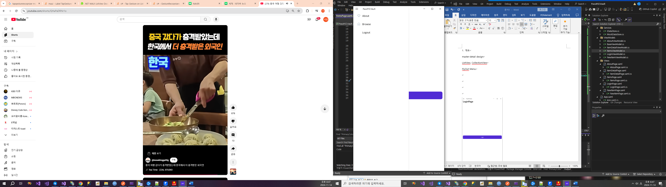

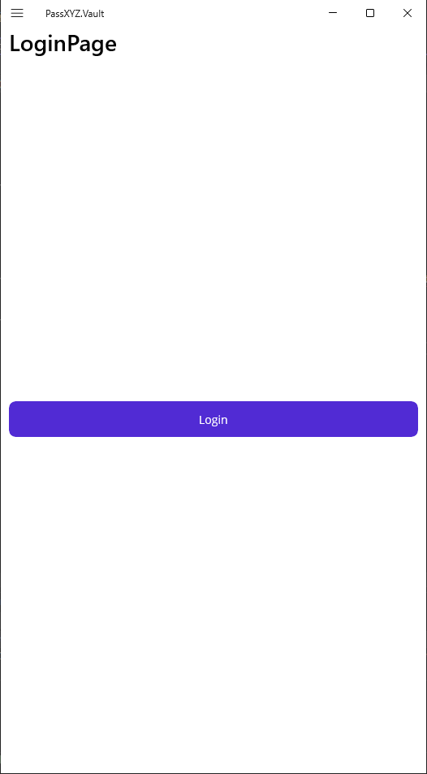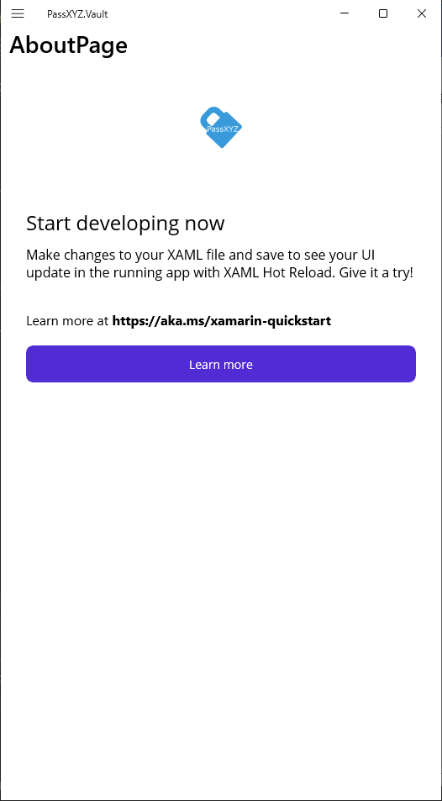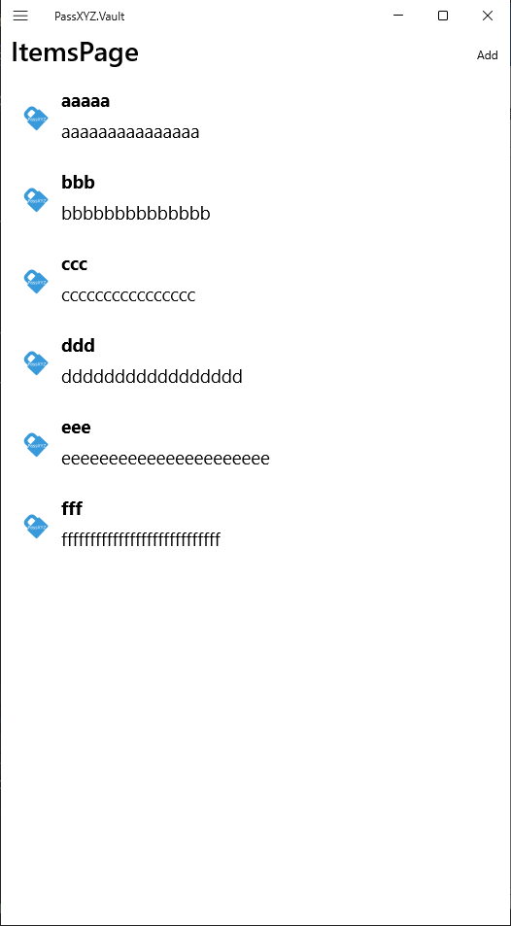 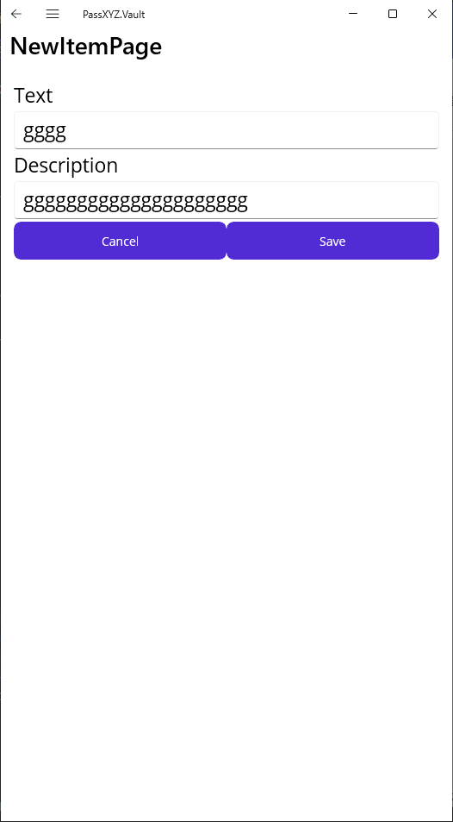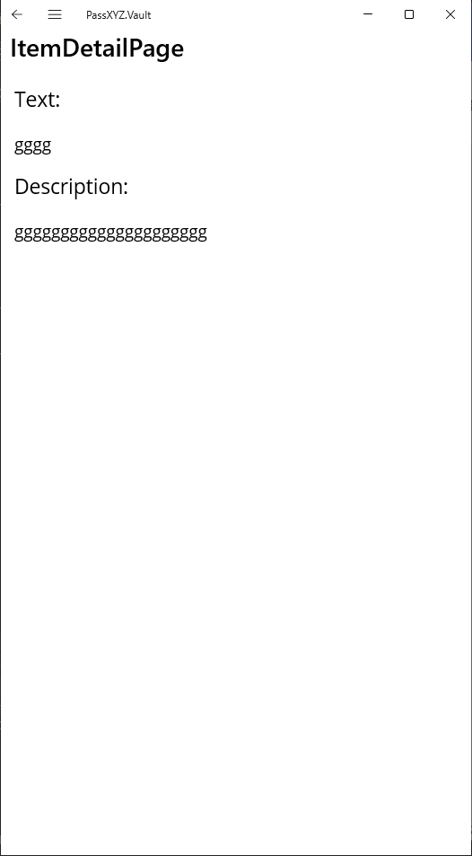

초기 구성

3. 구조

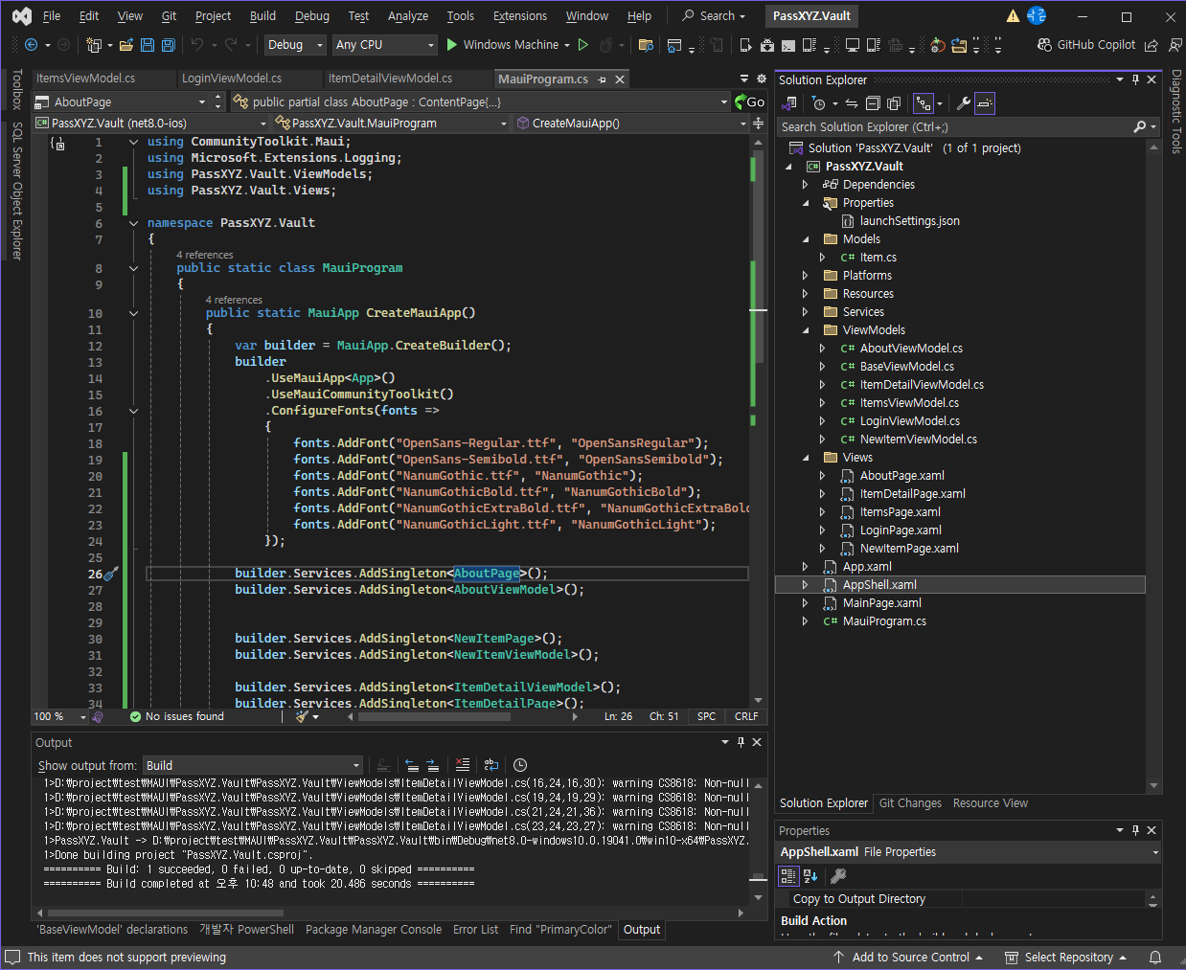

4. 소스

MauiProgram.cs

|  |
| --- |
| namespace PassXYZ.Vault  {  public static class MauiProgram  {  public static MauiApp CreateMauiApp()  {  var builder = MauiApp.CreateBuilder();  builder  .UseMauiApp<App>()  .UseMauiCommunityToolkit()  .ConfigureFonts(fonts =>  {  fonts.AddFont("OpenSans-Regular.ttf", "OpenSansRegular");  fonts.AddFont("OpenSans-Semibold.ttf", "OpenSansSemibold");  fonts.AddFont("NanumGothic.ttf", "NanumGothic");  fonts.AddFont("NanumGothicBold.ttf", "NanumGothicBold");  fonts.AddFont("NanumGothicExtraBold.ttf", "NanumGothicExtraBold");  fonts.AddFont("NanumGothicLight.ttf", "NanumGothicLight");  });  builder.Services.AddSingleton<AboutPage>();  builder.Services.AddSingleton<AboutViewModel>();    builder.Services.AddSingleton<NewItemPage>();  builder.Services.AddSingleton<NewItemViewModel>();  builder.Services.AddSingleton<ItemDetailViewModel>();  builder.Services.AddSingleton<ItemDetailPage>();  builder.Services.AddSingleton<ItemsViewModel>();  builder.Services.AddSingleton<ItemsPage>();  builder.Services.AddSingleton<LoginPage>();  builder.Services.AddSingleton<LoginViewModel>();  #if DEBUG  builder.Logging.AddDebug();  #endif  return builder.Build();  }  }  } |

MainPage.xaml

|  |
| --- |
| <?xml version="1.0" encoding="utf-8" ?>  <ContentPage xmlns="http://schemas.microsoft.com/dotnet/2021/maui"  xmlns:x="http://schemas.microsoft.com/winfx/2009/xaml"  x:Class="PassXYZ.Vault.MainPage">  <ScrollView>  <VerticalStackLayout  Padding="30,0"  Spacing="25">  <Image  Source="dotnet_bot.png"  HeightRequest="185"  Aspect="AspectFit"  SemanticProperties.Description="dot net bot in a race car number eight" />  <Label  Text="Hello, World!"  Style="{StaticResource Headline}"  SemanticProperties.HeadingLevel="Level1"  FontFamily="NanumGothic"/>  <Label  Text="Welcome to &#10;.NET Multi-platform App UI"  Style="{StaticResource SubHeadline}"  SemanticProperties.HeadingLevel="Level2"  SemanticProperties.Description="Welcome to dot net Multi platform App U I"  FontFamily="NanumGothic"/>  <Button  x:Name="CounterBtn"  Text="Click me"  SemanticProperties.Hint="Counts the number of times you click"  Clicked="OnCounterClicked"  HorizontalOptions="Fill"  FontFamily="NanumGothic"/>  </VerticalStackLayout>  </ScrollView>  </ContentPage> |

AppShell.xaml

|  |
| --- |
| <?xml version="1.0" encoding="UTF-8" ?>  <Shell  x:Class="PassXYZ.Vault.AppShell"  xmlns="http://schemas.microsoft.com/dotnet/2021/maui"  xmlns:x="http://schemas.microsoft.com/winfx/2009/xaml"  xmlns:local="clr-namespace:PassXYZ.Vault"  xmlns:views="clr-namespace:PassXYZ.Vault.Views"  Shell.FlyoutBehavior="Flyout"  Title="PassXYZ.Vault">  <TabBar>  <ShellContent Route="LoginPage"  ContentTemplate="{DataTemplate views:LoginPage}" />  </TabBar>  <FlyoutItem Title="About" Icon="tab_favorites.png" >  <ShellContent Route="AboutPage"  ContentTemplate="{DataTemplate views:AboutPage}" />  </FlyoutItem>  <FlyoutItem x:Name="RootItem" Title="Browse" Icon="tab_home.png">  <ShellContent Route="RootPage"  ContentTemplate="{DataTemplate views:ItemsPage}" />  </FlyoutItem>  <MenuItem Text="Logout" Clicked="OnMenuItemClicked">  </MenuItem>  </Shell> |

AppShell.xaml.cs

|  |
| --- |
| namespace PassXYZ.Vault  {  public partial class AppShell : Shell  {  public static AppShell? CurrentAppShell { get; private set; } = default!;  public AppShell()  {  InitializeComponent();  Routing.RegisterRoute(nameof(ItemDetailPage), typeof(ItemDetailPage));  //Routing.RegisterRoute(nameof(NotesPage), typeof(NotesPage));  Routing.RegisterRoute(nameof(NewItemPage), typeof(NewItemPage));  //Routing.RegisterRoute(nameof(SignUpPage), typeof(SignUpPage));  Routing.RegisterRoute(nameof(LoginPage), typeof(LoginPage));  //Routing.RegisterRoute(nameof(SearchPage), typeof(SearchPage));  Routing.RegisterRoute(nameof(ItemsPage), typeof(ItemsPage));  CurrentAppShell = this;  }  private async void OnMenuItemClicked(object sender, EventArgs e)  {  Debug.WriteLine("AppShell: Logout");  await Current.GoToAsync("//LoginPage");  }  }  } |

AboutPage.xaml

|  |
| --- |
| <?xml version="1.0" encoding="utf-8" ?>  <ContentPage xmlns="http://schemas.microsoft.com/dotnet/2021/maui"  xmlns:x="http://schemas.microsoft.com/winfx/2009/xaml"  x:Class="PassXYZ.Vault.Views.AboutPage"  xmlns:viewModel="clr-namespace:PassXYZ.Vault.ViewModels"  x:DataType="viewModel:AboutViewModel"  Title="AboutPage">  <Grid>  <Grid.RowDefinitions>  <RowDefinition Height="Auto" />  <RowDefinition Height="*" />  </Grid.RowDefinitions>  <StackLayout BackgroundColor="{DynamicResource PageBackgroundColor}" VerticalOptions="FillAndExpand" HorizontalOptions="Fill">  <StackLayout Orientation="Horizontal" HorizontalOptions="Center" VerticalOptions="Center">  <ContentView Padding="0,40,0,40" VerticalOptions="FillAndExpand">  <Image Source="passxyz_logo.png"  VerticalOptions="Center" HeightRequest="64" />  </ContentView>  </StackLayout>  </StackLayout>  <ScrollView Grid.Row="1">  <StackLayout Orientation="Vertical" Padding="30,24,30,24" Spacing="10">  <Label Text="Start developing now" FontSize="Title"/>  <Label Text="Make changes to your XAML file and save to see your UI update in the running app with XAML Hot Reload. Give it a try!"  FontSize="16" Padding="0,0,0,0"/>  <Label FontSize="16" Padding="0,24,0,0">  <Label.FormattedText>  <FormattedString>  <FormattedString.Spans>  <Span Text="Learn more at "/>  <Span Text="https://aka.ms/xamarin-quickstart"  FontAttributes="Bold"/>  </FormattedString.Spans>  </FormattedString>  </Label.FormattedText>  </Label>  <Button Margin="0,10,0,0" Text="Learn more"  Command="{Binding OpenWebCommand}"  BackgroundColor="{DynamicResource Primary}"  TextColor="White" />  </StackLayout>  </ScrollView>  </Grid>  </ContentPage> |

AboutPage.xaml.cs

|  |
| --- |
| public partial class AboutPage : ContentPage  {  public AboutPage(AboutViewModel vm)  {  InitializeComponent();  BindingContext = vm;  }  } |

LoginPage.xaml

|  |
| --- |
| <?xml version="1.0" encoding="utf-8" ?>  <ContentPage xmlns="http://schemas.microsoft.com/dotnet/2021/maui"  xmlns:x="http://schemas.microsoft.com/winfx/2009/xaml"  xmlns:viewModel ="clr-namespace:PassXYZ.Vault.ViewModels"  x:DataType="viewModel:LoginViewModel"  x:Class="PassXYZ.Vault.Views.LoginPage"  Title="LoginPage">  <ContentPage.Content>  <StackLayout Padding="10,0,10,0" VerticalOptions="Center">  <Button VerticalOptions="Center" IsEnabled="True" Text="Login" Command="{Binding LoginCommand}"/>  </StackLayout>  </ContentPage.Content>  </ContentPage> |

LoginPage.xaml.cs

|  |
| --- |
| public partial class LoginPage : ContentPage  {  public LoginPage(LoginViewModel vm)  {  InitializeComponent();  BindingContext = vm;  }  } |

ItemsPage.xaml

|  |
| --- |
| <?xml version="1.0" encoding="utf-8" ?>  <ContentPage xmlns="http://schemas.microsoft.com/dotnet/2021/maui"  xmlns:x="http://schemas.microsoft.com/winfx/2009/xaml"  x:Class="PassXYZ.Vault.Views.ItemsPage"  xmlns:viewModel="clr-namespace:PassXYZ.Vault.ViewModels"  xmlns:model="clr-namespace:PassXYZ.Vault.Models"  x:DataType="viewModel:ItemsViewModel"  Title="ItemsPage">  <ContentPage.ToolbarItems>  <ToolbarItem Text="Add" Command="{Binding AddItemCommand}" />  </ContentPage.ToolbarItems>  <StackLayout>  <ListView x:Name="ItemsListView"  ItemsSource="{Binding *Items*}"  VerticalOptions="FillAndExpand"  HasUnevenRows="False"  RowHeight="84"  RefreshCommand="{Binding LoadItemsCommand}"  IsPullToRefreshEnabled="true"  IsRefreshing="{Binding *IsBusy*, *Mode*=OneWay}"  CachingStrategy="RetainElement"  >  <ListView.ItemTemplate>  <DataTemplate>  <ViewCell>  <StackLayout>  <Grid Padding="10" x:DataType="model:Item" >  <Grid.RowDefinitions>  <RowDefinition Height="32" />  <RowDefinition Height="32" />  </Grid.RowDefinitions>  <Grid.ColumnDefinitions>  <ColumnDefinition Width="Auto" />  <ColumnDefinition Width="Auto" />  </Grid.ColumnDefinitions>  <Grid Grid.RowSpan="2" Padding="10">  <Grid.ColumnDefinitions>  <ColumnDefinition Width="32" />  </Grid.ColumnDefinitions>  <Image Grid.Column="0" Source="passxyz_logo.png" HorizontalOptions="Fill" VerticalOptions="Fill" />  </Grid>  <Label Text="{Binding Text}"  Grid.Column="1"  LineBreakMode="NoWrap"  MaxLines="1" Style="{DynamicResource *ListItemTextStyle*}"  FontAttributes="Bold"  FontSize="Small" />  <Label Text="{Binding Description}"  Grid.Row="1" Grid.Column="1"  LineBreakMode="TailTruncation"  MaxLines="1"  Style="{DynamicResource *ListItemDetailTextStyle*}"  FontSize="Small" />  <Grid.GestureRecognizers>  <TapGestureRecognizer  NumberOfTapsRequired="1"  Command="{Binding *Source*={RelativeSource *AncestorType*={x:Type viewModel:ItemsViewModel}}, *Path*=ItemTappedCommand}"  CommandParameter="{Binding .}">  </TapGestureRecognizer>  </Grid.GestureRecognizers>  </Grid>      </StackLayout>    </ViewCell>  </DataTemplate>  </ListView.ItemTemplate>  </ListView>  </StackLayout>  </ContentPage> |

ItemsPage.xaml.cs

|  |
| --- |
| public partial class ItemsPage : ContentPage  {  private readonly ItemsViewModel _viewModel;  public ItemsPage(ItemsViewModel vm)  {  InitializeComponent();  BindingContext = _viewModel= vm;  }  protected override void OnAppearing()  {  base.OnAppearing();  _viewModel.OnAppearing();  }  } |

ItemDetailPage.xaml

|  |
| --- |
| <?xml version="1.0" encoding="utf-8" ?>  <ContentPage xmlns="http://schemas.microsoft.com/dotnet/2021/maui"  xmlns:x="http://schemas.microsoft.com/winfx/2009/xaml"  x:Class="PassXYZ.Vault.Views.ItemDetailPage"  xmlns:viewModel="clr-namespace:PassXYZ.Vault.ViewModels"  x:DataType="viewModel:ItemDetailViewModel"  Title="ItemDetailPage">  <StackLayout Spacing="20" Padding="15">  <Label Text="Text:" FontSize="Medium" />  <Label Text="{Binding Text}" FontSize="Small"/>  <Label Text="Description:" FontSize="Medium" />  <Label Text="{Binding Description}" FontSize="Small"/>  </StackLayout>  </ContentPage> |

ItemDetailPage.xaml.cs

|  |
| --- |
| public partial class ItemDetailPage : ContentPage  {  public ItemDetailPage(ItemDetailViewModel vm)  {  InitializeComponent();  BindingContext = vm;  }  } |

NewItemPage.xaml

|  |
| --- |
| <?xml version="1.0" encoding="utf-8" ?>  <ContentPage xmlns="http://schemas.microsoft.com/dotnet/2021/maui"  xmlns:x="http://schemas.microsoft.com/winfx/2009/xaml"  x:Class="PassXYZ.Vault.Views.NewItemPage"  xmlns:viewModel="clr-namespace:PassXYZ.Vault.ViewModels"  x:DataType="viewModel:NewItemViewModel"  Title="NewItemPage">  <StackLayout Spacing="3" Padding="15">  <Label Text="Text" FontSize="Medium" />  <Entry Text="{Binding Text, *Mode*=TwoWay}" FontSize="Medium" />  <Label Text="Description" FontSize="Medium" />  <Editor Text="{Binding Description, *Mode*=TwoWay}" AutoSize="TextChanges" FontSize="Medium" Margin="0" />  <StackLayout Orientation="Horizontal">  <Button Text="Cancel" Command="{Binding CancelCommand}" HorizontalOptions="FillAndExpand"></Button>  <Button Text="Save" Command="{Binding SaveCommand}" HorizontalOptions="FillAndExpand"></Button>  </StackLayout>  </StackLayout>  </ContentPage> |

NewItemPage.xaml.cs

|  |
| --- |
| public partial class NewItemPage : ContentPage  {  public NewItemPage(NewItemViewModel vm)  {  InitializeComponent();  BindingContext = vm;  }  } |